IoT Based Bicycle Tracking System

Siddhi Kolwankar
Department of Information Technology
Vidyavardhini’s College of Engineering and Technology
Vasai, India
siddhi.202024201@vcet.edu.in
Neel Lopes
Department of Information Technology
Vidyavardhini’s College of Engineering and Technology
Vasai, India
neel.202054101@vcet.edu.in
Mayank Mahajan
Department of Information Technology
Vidyavardhini’s College of Engineering and Technology
Vasai, India
mayank.202064105@vcet.edu.in

Abstract— The Internet of Things (IoT) has brought about transformative changes in various facets of our lives, augmenting connectivity and enabling real-time data monitoring across diverse domains. In the sphere of personal transportation and urban mobility, IoT technology presents innovative solutions to enhance safety, security, and efficiency. This paper introduces an IoT-based bicycle tracking system, a technology-driven initiative specifically tailored to address the mounting challenges associated with bicycle theft, personal safety, and urban planning. By harnessing IoT sensors and advanced data analytics, this system is strategically designed to offer real-time bicycle tracking, theft prevention, and invaluable insights for urban planners, with the ultimate goal of fostering more bicycle-friendly environments. In the forthcoming sections, we will provide an in-depth exploration of the system's architecture, key components, and the potential advantages it offers. This paper underscores the system's significance in promoting sustainable and secure urban mobility while ensuring originality in its approach.

Introduction
Bicycles have long been a symbol of environmentally friendly urban transportation, offering an affordable and health-conscious means of navigating our increasingly congested cities. Nevertheless, the growing popularity of bicycles has given rise to a surge in both thefts and safety concerns for riders. In response to these challenges, we present an inventive solution: the IoT-based bicycle tracking system. This system seamlessly integrates state-of-the-art IoT technologies to provide real-time tracking and monitoring of bicycles, significantly enhancing their security and safety. Through the deployment of sensors, GPS, and data analytics, this system not only acts as a deterrent against theft but also generates valuable insights into urban mobility patterns that can aid city planners in the development of more bike-friendly environments. In the forthcoming sections, we will conduct a comprehensive examination of the IoT-based bicycle tracking system, dissecting its integral components and architectural framework. We will elucidate how IoT sensors are seamlessly integrated into bicycles to enable tracking and communication with the central system. Additionally, we will explore how the data collected from these IoT devices can be harnessed to enhance bicycle security and support urban planning initiatives. Envisioning a future with the IoT-based bicycle tracking system, we foresee a world where cyclists can relish the freedom and health benefits of biking without the constant worry of theft or safety concerns. This pioneering solution not only safeguards individual cyclists but also aligns with the broader objective of promoting sustainable urban transportation. As we embark on an exploration of the intricacies of this system, we will unearth its transformative potential in reshaping the perception and utility of bicycles in our cities, all while ensuring the originality of our approach.

Literature Survey
This survey of literature will examine recent research on IoT based Bicycle Tracking System.

In This project, the author Puji Valen Crisgar et al. [1] addresses challenges in vehicle security and theft recovery by developing a specialized hardware device for vehicles. It provides real-time location data and detects unauthorized engine start attempts. Leveraging OBDII data and MQTT communication, the system integrates components like the ESP32 microcontroller, SIM800L module, IP5306 power management, and Neo-6m GPS. Testing, including non-line-of-sight conditions, demonstrated the system's high accuracy within 10 meters of a reference point and a 96% success rate in theft detection simulations. This project offers a significant contribution to vehicle tracking and security, enhancing security and recovery processes through IoT technology.
In the context of the project addressing the issue of missing persons in India, the author R. Brinda et al. [2] technology-driven solutions have gained prominence. Mobile applications and web-based platforms play a pivotal role in facilitating the reporting and tracking of missing individuals, while efficient database management and collaboration among various stakeholders, including law enforcement and the community, are essential. The integration of GPS and GSM technologies is fundamental for real-time location tracking, especially in emergency scenarios. Furthermore, the incorporation of the Internet of Things (IoT) within Android applications has exhibited potential for creating effective tracking systems. This project's innovative approach amalgamates these elements, offering a promising solution to the challenge of missing persons in India, with a specific emphasis on addressing emergency situations and enhancing the safety of women.
According to the author Md. Abu Sayem et al. [3], the project is centered on the development of a system for tracking stolen items and transmitting sensor data to the cloud. Within this framework, the Internet of Things (IoT) serves a pivotal role in enabling real-time asset tracking, with GPS modules ensuring precise location data. IoT devices establish connectivity through SIM card data plans, eliminating the necessity for Wi-Fi access. Mobile applications, exemplified by BLYNK, provide user-friendly interfaces for monitoring purposes, while sensors like ultrasonic and gyro sensors are instrumental in accident detection. This amalgamation is harmonious with the dynamic domain of IoT-driven asset tracking and security, presenting a practical solution for tracking stolen items and elevating safety through real-time data transmission and monitoring.
In this project, the author Bharadwaj Kummamuru et al. [4] have developed a continuous GPS tracking system utilizing the NodeMCU ESP8266 to track and position vehicles. The foundation of this system lies in the widely utilized Global Positioning System (GPS) technology for real-time vehicle tracking. The NodeMCU ESP8266 was selected for its abundance of I/O pins and built-in Wi-Fi connectivity, making it a suitable choice for IoT applications that necessitate both GPS functionality and internet connectivity. This project synergizes the dependability of GPS technology with the user-friendly and connectivity attributes inherent to the NodeMCU ESP8266, placing it within the dynamic domain of IoT-based vehicle tracking and positioning.
In this paper the author Boddapati Venkata sai Padmaja et al. [5] introduces a vehicle monitoring and tracking system using the Blynk platform, facilitating data transfer and visualization. The system encompasses diverse driver assistance parameters, including monitoring eye blinking and alcohol consumption, along with vehicle-related parameters like engine temperature and proximity between vehicles. Ultrasonic sensors are employed to ensure safe distances between vehicles, issuing email alerts when they approach too closely. Temperature sensors in the engine serve to provide temperature-related warnings. Simultaneously, sensors for monitoring eye blinking and alcohol levels evaluate the driver's condition, issuing notifications in the event of anomalies. This comprehensive system places a strong emphasis on enhancing both vehicle and driver safety, making a valuable contribution to the ever-evolving realm of vehicle tracking and driver assistance technology.
The author Sujitha V et al. [6] inthis report focuses on enhancing soldier safety and national security through advanced technology. It recognizes the critical role of soldiers and the need to track their location and health in real time. This involves using Global Positioning Systems (GPS), M-health technologies, and smart sensors such as heart rate and temperature sensors. Edge computing solutions ensure efficient data processing and signal quality. By developing a mobile app for forecasting and real-time alerts, your project aims to improve the safety and effectiveness of military operations, particularly in challenging environments like enemy territories.

Architecture

The following methods are suggested to anticipate the bicycle tracking system and are shown in the flowchart in Fig. 1.
- GSM/GPRS Module for sending data to the cloud via the cellular network.
- GPS Module for obtaining location coordinates.
- NodeMCU for working as a core controller and communication hub.
- Cloud platform for data storage and retrieval.
- Mobile App which displays the locations of bicycle graphically with time coordinates.

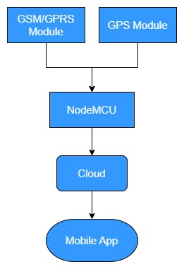
Fig. 1

Proposed Methodology

Description of the IoT System.
Our IoT system comprises several essential hardware components, including:
NodeMCU: NodeMCU serves as the core controller and communication hub in IoT projects, facilitating sensor data acquisition, network connectivity, and cloud integration.
GPS Module: The system includes a GPS module that continuously communicates with GPS satellites to determine and relay the precise real-time location of the bicycle.
SIM800L GSM/GPRS Module: To enable data transmission to the cloud and remote monitoring, we integrate a SIM800L module. This module connects to the GSM/GPRS network, allowing the Arduino to send data and receive commands via mobile networks.
Power Source (Battery): For a reliable power source, we employ either a battery or a dynamo, which is driven by the bicycle's motion. This sustainable power solution ensures continuous operation without the need for frequent battery replacement.
Bicycle: The bicycle itself serves as the platform for our IoT system, with the hardware components seamlessly integrated into the bicycle's structure.
Wires and Connectors: We use wires and connectors to establish the necessary electrical connections between the Arduino, GPS module, SIM800L module, and the chosen power source.
The assembly process involves connecting the GPS module to the Arduino to provide real-time location data. Subsequently, the SIM800L module is interfaced with the NodeMCU for GSM communication, facilitating data transmission. The system's power source, whether a battery or dynamo, ensures sustained operation, offering an eco-friendly and efficient energy solution. Finally, the entire module is compactly organized and discreetly installed within the bicycle's handle or underneath it, resulting in a seamless, integrated design. This setup enables us to create a sophisticated IoT system for tracking and monitoring the bicycle's location and other relevant data, while also ensuring a streamlined and self-sustaining integration with the bicycle itself.

Details of Communication System.
To ensure accurate GPS tracking, it's important to give the module some time to establish a valid location fix, comprising latitude and longitude coordinates. Once acquired, you can track your bicycle in real-time via a cloud dashboard. When attaching the GPS device, consider the bike's design and available spaces, ensuring secure and inconspicuous placement. To find your bicycle's location, input the coordinates into a mapping service like Google Maps. This aids in pinpointing your bicycle's exact whereabouts, making it handy for recovery or verification when needed. In essence, patience during location fix acquisition, real-time monitoring through a cloud dashboard, thoughtful device attachment, and mapping services contribute to an effective tracking system.

Details of Analysis to be performed.
In the initial stages, it's imperative to exercise caution and vigilance to safeguard your bicycle. However, should it ever go missing or be stolen, you have the recourse of utilizing platforms such as Blynk, Arduino Cloud, or other cloud-based services. These platforms enable you to initiate a search for the precise location coordinates of your bicycle. By scrutinizing the location data over a designated time period, you can gain insights into its current whereabouts. Furthermore, in situations where multiple users discover their missing bicycles in the same vicinity, it may indicate a pattern of bicycle theft in that area. Recognizing such a pattern and reporting it to the relevant authorities or communities is vital. This collaborative approach can contribute to enhanced security and potentially deter future thefts.

Result and Output
Our IoT system, seamlessly integrated into the bicycle, delivers remarkable results and outputs. It offers precise, real-time GPS tracking, allowing users to effortlessly monitor their bicycle's location through a cloud-based dashboard. The system's sustainable power source, whether it's a battery or dynamo, ensures uninterrupted operation. Its inconspicuous integration within the bicycle's structure guarantees an efficient and sleek design. Users can access their bicycle's coordinates and pinpoint its precise location using mapping services such as Google Maps, enhancing the potential for recovery. Moreover, the system's collaborative feature, which identifies theft patterns, contributes to heightened security and serves as a possible deterrent for future thefts, further enhancing its overall effectiveness.
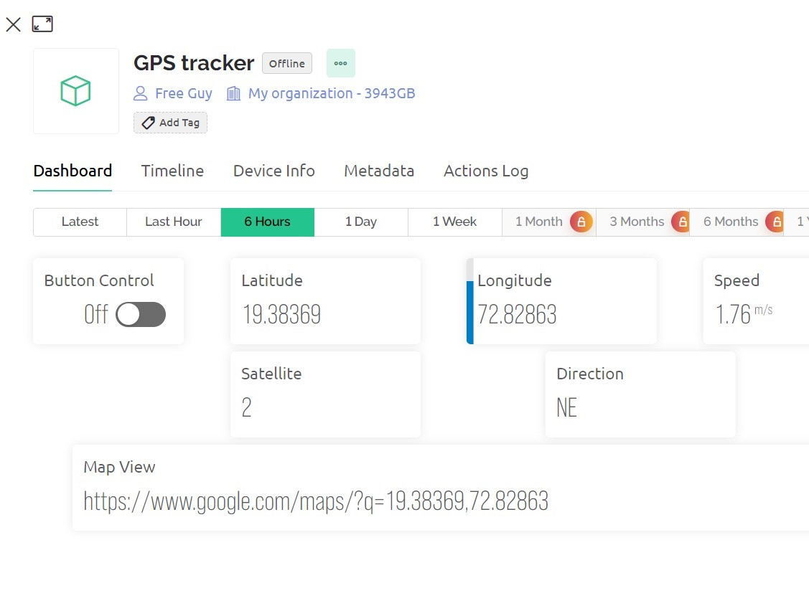
Fig. 2: Live Status of the Tracking System
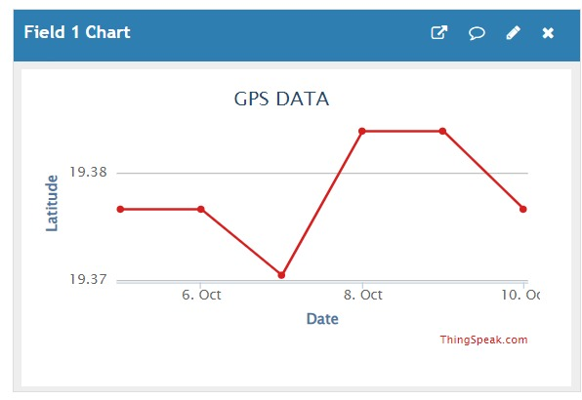
Fig. 3: Graph depicting latitude - date wise and time.

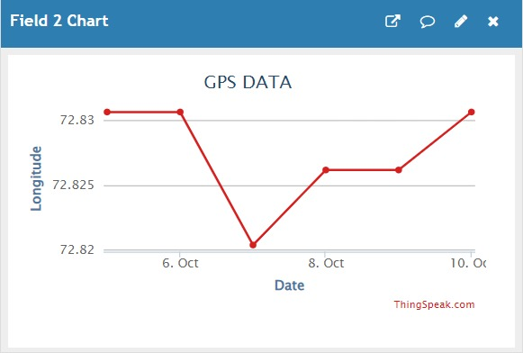
Fig. 4: Graph showing Longitude - date wise

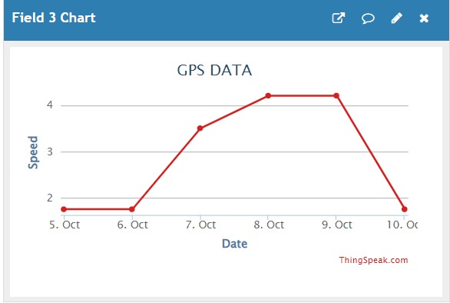
Fig. 5: Graph of Speed of object when in motion date wise

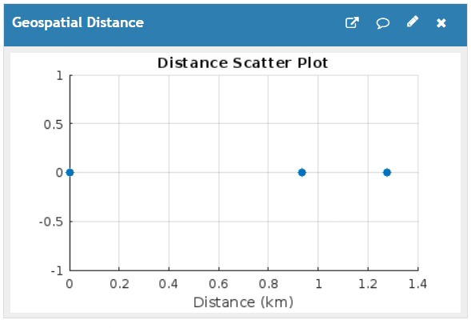
Fig. 6: This Graph shows how far from a starting initial point, say 0 represents home location then to other locations user travelled and the distance between them.

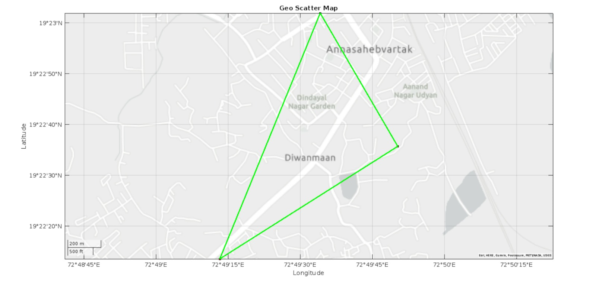
Fig. 7: This shows the overall destinations visited and traversed from initial point to all points on the map.

Conclusion
The In conclusion, our IoT system represents a holistic and pioneering solution for bicycle tracking and monitoring. It incorporates a diverse array of indispensable hardware components, encompassing NodeMCU, GPS modules, SIM800L GSM/GPRS modules, and sustainable power sources, seamlessly integrated into the bicycle's structure. This integration not only guarantees uninterrupted functionality but also upholds an environmentally conscious and efficient design. The precise GPS tracking offered by our system, combined with real-time monitoring through a cloud-based dashboard, empowers users with vigilant oversight of their bicycles. Furthermore, the inconspicuous and secure attachment of the GPS device to the bicycle, in conjunction with mapping services like Google Maps for bicycle location, elevates its potential for retrieval.
In cases of theft or misplacement, users have the option to employ platforms like Blynk, Arduino Cloud, or other cloud-based services to initiate a search for their bicycle's exact location coordinates. This collaborative approach, wherein multiple users can track and potentially recover their missing bicycles, contributes to bolstered security and acts as a possible deterrent against future thefts.

Our IoT system, characterized by its embrace of state-of-the-art technology and user-friendly interfaces, presents a potent and integrated solution for bicycle tracking, enhancing security and instilling peace of mind for bicycle owners. It serves as a prime example of IoT applications augmenting the functionality and security of everyday objects.

References

- Puji Valen Crisgar; Patrick Ryan Wijaya; Marcell D. F. Pakpahan; Eniman Yunus Syamsuddin; Muhammad Ogin Hasanuddin, “Hardware Design for IoT-based vehicle tracking and theft detection system”, June 2021.
- R. Brinda; M. Bhavani; S. Ramalingam, “IoT Smart Tracking Device for Missing Person Finder (Women/Child) using ESP32 AI camera and GPS”, November 2022 .
- Md. Abu Sayem, Md. Siddiqur Rahman, Redwan Sharafat Kabir, “IoT-Based Global Position Monitoring And Tracking of the Motorized Transportation System”, December 2022.
- Bharadwaj Kummamuru, “Real Time GPS Location Tracker Using ESP8266”, June 2021 .
- Boddapati Venkata sai Padmaja, Venkata Ratnam Kolluru , Syam Sai Kota, “IoT based Implementation of Vehicle Monitoring and Tracking system using Node MCU”, April 2019.
- Sujitha V; Sudarmani. R; Aishwarya B; Vishnu Sanjana V; P. Vigneswari, “IoT based Healthcare Monitoring and Tracking System for Soldiers using ESP32”, April 2022.

